Note to myself

- Clone repo: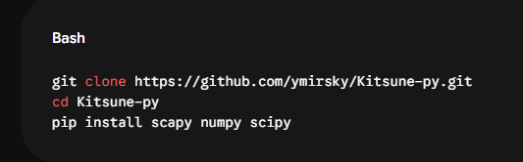
- The repo downloaded already have the dataset we need 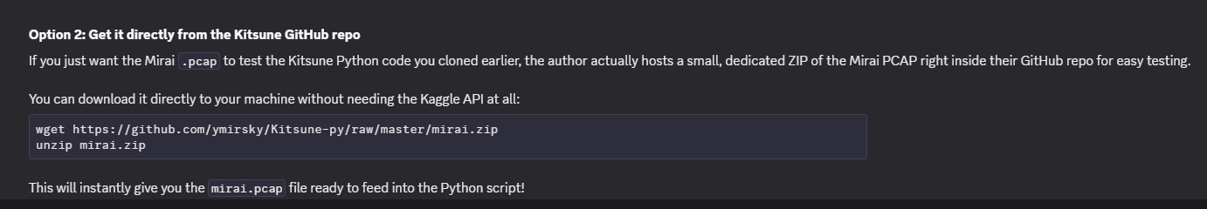
- Install cython to fix bug from the code: pip install cython
- Install tshark and then turnoff AppArmor for it: “sudo apt install tshark -y”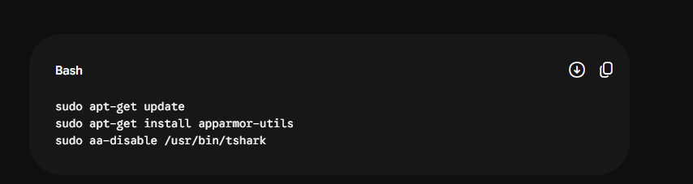
- Run this to fix the numpy legacy error: “ find ~/final/Kitsune-py -type f -name "*.py" -exec sed -i 's/numpy\.Inf/numpy.inf/g' {} +”
- Fix the code first 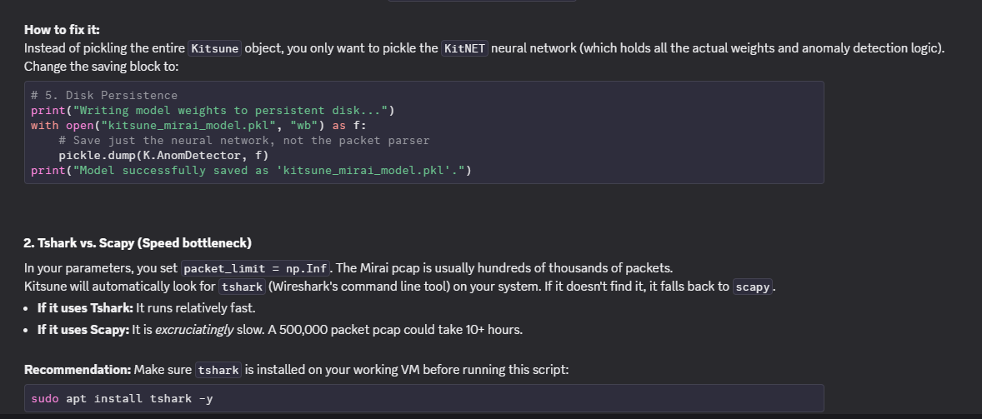

FULL code here: (remember to fix it first)

from Kitsune import *
import numpy as np
import time
import pickle

# 1. Dataset and Run Parameters
path = "mirai.pcap"
packet_limit = np.Inf

# 2. KitNET Architecture Parameters
maxAE = 10 # Maximum size for any autoencoder in the ensemble layer
FMgrace = 5000 # Number of packets used to incrementally learn the feature mapping
ADgrace = 50000 # Number of packets used to train the anomaly detector (the ensemble)

# 3. Pipeline Initialization
print(f"Loading {path} and initializing the Kitsune pipeline...")
K = Kitsune(path, packet_limit, maxAE, FMgrace, ADgrace)

print("Starting packet processing and model training...")
RMSEs = []
i = 0
start_time = time.time()

# 4. Training Loop (Online Learning)
while True:
i += 1

# Terminal feedback to ensure the SSH session does not appear frozen
if i % 25000 == 0:
print(f"Processed {i} packets...")

# Extract features, update the model, and score the packet
rmse = K.proc_next_packet()

# -1 indicates end of file or parsing error
if rmse == -1:
break

RMSEs.append(rmse)

end_time = time.time()
print(f"\nPipeline complete. Total packets processed: {i-1}")
print(f"Execution time: {end_time - start_time:.2f} seconds")

# 5. Disk Persistence
print("Writing model weights to persistent disk...")
with open("kitsune_mirai_model.pkl", "wb") as f:
pickle.dump(K, f)
print("Model successfully saved as 'kitsune_mirai_model.pkl'.")

Part 2:

(evaluate_threshold.py )

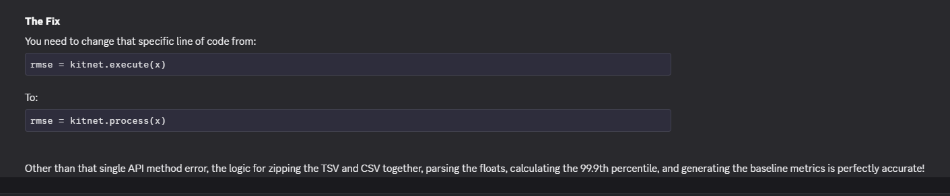

import pickle
import numpy as np
import csv
import time

model_path = "kitsune_mirai_model.pkl"
tsv_path = "mirai.pcap.tsv"
csv_path = "mirai_labels.csv"

# 1. Load the trained KitNET ensemble
print(f"Loading defensive model from {model_path}...")
with open(model_path, "rb") as f:
kitnet = pickle.load(f)

benign_rmses = []
malicious_rmses = []

print("Starting inference across feature vectors...")
start_time = time.time()

# 2. Stream through both files simultaneously
with open(tsv_path, "r") as f_tsv, open(csv_path, "r") as f_csv:
tsv_reader = csv.reader(f_tsv, delimiter='\t')
csv_reader = csv.reader(f_csv)

# Skip the single header row in the TSV discovered in your consistency check
next(tsv_reader)

i = 0
for tsv_row, csv_row in zip(tsv_reader, csv_reader):
i += 1

# Parse the 100-feature vector and the label
x = np.array(tsv_row, dtype=float)
label = int(csv_row[0])

# 3. Pure Inference: use execute() to score the vector without updating weights
rmse = kitnet.process(x)

# 4. Categorize the score based on the true label
if label == 0:
benign_rmses.append(rmse)
else:
malicious_rmses.append(rmse)

if i % 100000 == 0:
print(f"Scored {i} samples...")

end_time = time.time()
print(f"\nInference complete in {end_time - start_time:.2f} seconds.")

# 5. Calculate the Threshold and Baseline Metrics
benign_rmses = np.array(benign_rmses)
malicious_rmses = np.array(malicious_rmses)

# Set the detection threshold at the 99.9th percentile of benign traffic
# This accounts for natural network noise while remaining strict
threshold = np.percentile(benign_rmses, 99.9)

detected_attacks = np.sum(malicious_rmses > threshold)
missed_attacks = np.sum(malicious_rmses <= threshold)
detection_rate = (detected_attacks / len(malicious_rmses)) * 100
evasion_rate = 100 - detection_rate

print("\n--- Baseline Defensive Metrics ---")
print(f"Total Benign Packets: {len(benign_rmses)}")
print(f"Total Malicious Packets: {len(malicious_rmses)}")
print(f"Calculated Alert Threshold: {threshold:.4f}")
print(f"Baseline Detection Rate: {detection_rate:.2f}%")
print(f"Baseline Evasion Rate: {evasion_rate:.2f}%")

